**Unit 5-Support Vector Machines and Unsupervised Learning**

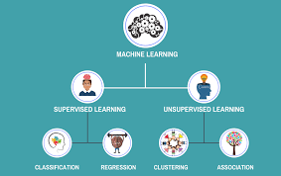

**Support Vector Machines (SVM):**

Support Vector Machines are a powerful supervised learning algorithm used for classification and regression tasks. The primary goal of SVM is to find the best hyperplane that can effectively separate data points belonging to different classes in a given dataset. In two dimensions, the hyperplane is a line, and in higher dimensions, it becomes a plane.

**The "**support vectors" are the data points closest to the hyperplane, and they play a crucial role in determining the optimal hyperplane. The margin of an SVM is the distance between the support vectors of the two classes, and SVM aims to maximize this margin. The larger the margin, the better the generalization of the model to new, unseen data.

**SVM** is effective in scenarios where the data is not linearly separable by transforming the data into a higher-dimensional space using the kernel trick. This transformation allows the SVM to find a hyperplane that can separate the data in the new feature space.

**Unsupervised Learning:**

Unsupervised learning is a type of machine learning where the model is not provided with labeled data. In contrast to supervised learning, where the algorithm learns from input-output pairs, unsupervised learning aims to find patterns and structure within the data without explicit labels.

The primary tasks in unsupervised learning are clustering and dimensionality reduction:

* **Clustering:** Clustering algorithms group similar data points together based on their features or proximity. The goal is to identify natural groupings or clusters within the data. Common clustering algorithms include k-means, hierarchical clustering, and DBSCAN.
* **Dimensionality Reduction**: Dimensionality reduction techniques are used to reduce the number of features in the data while preserving essential information. Principal Component Analysis (PCA) and t-distributed Stochastic Neighbor Embedding (t-SNE) are common methods for dimensionality reduction.

Both SVM and unsupervised learning are essential tools in a data scientist's toolbox, and they find applications across various domains in the field of machine learning.

**Support Vector Machines**

Support Vector Machines (SVM) is a supervised learning algorithm used for classification and regression tasks. It is particularly powerful for solving binary classification problems, where the goal is to separate data points into two distinct classes based on their features.

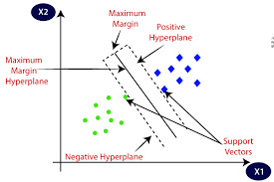

**How Support Vector Machines Work:**

The primary idea behind SVM is to find the optimal hyperplane that can best separate the data points of different classes. In two dimensions, the hyperplane is simply a line, and in higher dimensions, it becomes a plane. The hyperplane is chosen in such a way that it maximizes the margin between the two classes.

Here's a step-by-step explanation of how SVM works:

1. **Data Representation:** Each data point in the dataset is represented as a feature vector in a multi-dimensional space. For binary classification, each feature vector has two components, (x1, x2), where x1 and x2 represent the two features.
2. **Finding the Hyperplane:** The goal is to find the hyperplane that best separates the data points of the two classes. The hyperplane is chosen in a way that maximizes the margin, i.e., the distance between the two classes' support vectors.
3. **Support Vector**s: The support vectors are the data points that are closest to the hyperplane. These are the critical data points that influence the position of the hyperplane.
4. **Margin Optimization:** SVM aims to maximize the margin between the two classes while ensuring that the support vectors lie on the correct side of the hyperplane. This process is known as margin optimization.
5. **Dealing with Non-Linear Data:** In cases where the data is not linearly separable in the original feature space, SVM can transform the data into a higher-dimensional space using the kernel trick. Popular kernel functions include the polynomial kernel, radial basis function (RBF) kernel, and sigmoid kernel.
6. **Kernel Trick:** The kernel trick allows SVM to efficiently compute the dot product between feature vectors in the higher-dimensional space without explicitly transforming the data. This makes SVM effective in handling non-linearly separable data.
7. **C and Gamma Parameters**: In SVM, there are hyperparameters, C and gamma, that need to be tuned. The parameter C controls the trade-off between maximizing the margin and allowing misclassifications (soft margin vs. hard margin). The parameter gamma defines the influence of each training example and affects the shape of the decision boundary.

**Advantages of SVM:**

* Effective in high-dimensional spaces.
* Memory efficient as it only uses support vectors for decision-making.
* Versatile due to various kernel functions to handle non-linear data.
* Robust against overfitting with proper parameter tuning.

**Disadvantages of SVM:**

* Computationally intensive, especially with large datasets.
* Difficult to interpret the complex decision boundaries in high-dimensional spaces.
* Tuning hyperparameters requires expertise and experimentation.

**Maximal Margin Classifier**

The Maximal Margin Classifier is a special case of the Support Vector Machine (SVM) algorithm in which the goal is to find the hyperplane that maximizes the margin between the two classes in a binary classification problem. It is also known as the Hard Margin Classifier because it does not allow any misclassifications (i.e., it enforces a strict margin around the classes).

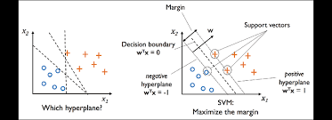

**Key Concepts:**

**Margin:** The margin in SVM is the distance between the hyperplane and the nearest data points of each class (support vectors). The Maximal Margin Classifier aims to maximize this margin.

**Hyperplane:** In a two-dimensional space, the hyperplane is a straight line that separates the data points of the two classes. In higher-dimensional spaces, the hyperplane becomes a hyperplane (a flat affine subspace).

**Support Vectors**: The support vectors are the data points that lie closest to the hyperplane and play a critical role in determining the position of the hyperplane.

Working of the Maximal Margin Classifier:

The main idea behind the Maximal Margin Classifier is to find the hyperplane that separates the two classes while keeping the margin between the classes as wide as possible. This hyperplane should not allow any data points from either class to cross into the other class's region.

**The steps to find the Maximal Margin Classifier are as follows**:

1. **Data Representation:** Represent the data as feature vectors in a multi-dimensional space. For binary classification, each feature vector has two components (x1, x2) representing the two features.
2. **Finding the Hyperplane:** The Maximal Margin Classifier aims to find the hyperplane that separates the two classes with the largest possible margin. This hyperplane will have support vectors from both classes.
3. **Margin Optimization:** The optimization problem is to maximize the margin while ensuring that all data points are correctly classified. This is a constrained optimization problem where the objective is to maximize the margin, subject to the constraint that all data points must lie on the correct side of the hyperplane.
4. **Hard Margin vs. Soft Margin:** The Maximal Margin Classifier enforces a hard margin, which means it does not allow any misclassifications. If the data is not linearly separable (i.e., no hyperplane can separate the classes without any misclassifications), the Maximal Margin Classifier would fail.
5. **Non-Linear Data**: When dealing with non-linearly separable data, the Maximal Margin Classifier would not be able to find a hyperplane that perfectly separates the classes. In such cases, soft margin SVM or kernel SVM (using the kernel trick) can be used to handle the non-linearity.

The Maximal Margin Classifier is an elegant concept that finds the most optimal separation between classes when the data is linearly separable. However, real-world data is often not perfectly linearly separable, which is why soft margin SVM or kernel SVM variants are more commonly used as they allow for some margin of error to handle non-linear data and potential outliers.

**Support Vector Classifiers**

Support Vector Classifiers (SVC) are a type of supervised learning algorithm that belong to the family of Support Vector Machines (SVM). SVC is used for binary classification tasks, where the goal is to separate data points into two classes based on their features.

**Key Concepts:**

**Hyperplane:** As with SVM, SVC aims to find a hyperplane that best separates the data points of different classes. In two dimensions, the hyperplane is a straight line, and in higher dimensions, it becomes a flat affine subspace.

**Margin:** The margin in SVC is the distance between the hyperplane and the nearest data points of each class (support vectors). SVC aims to find a hyperplane that achieves a reasonable margin while allowing for some misclassifications.

**Support Vectors:** Support vectors are the data points closest to the hyperplane and are crucial for determining the position of the hyperplane.

Working of Support Vector Classifiers:

The key idea behind SVC is to find the hyperplane that separates the two classes while allowing a certain amount of misclassification. Unlike the Maximal Margin Classifier (hard margin SVM), SVC is more flexible and can handle situations where the data is not perfectly linearly separable.

The steps to find the Support Vector Classifier are similar to SVM:

Data Representation: Represent the data as feature vectors in a multi-dimensional space. Each feature vector has components (x1, x2) representing the two features.

**Finding the Hyperplane:** SVC aims to find the hyperplane that separates the two classes, allowing for some margin of error. This hyperplane will also have support vectors from both classes.

**Margin Optimization:** The optimization problem in SVC is to find a hyperplane that maximizes the margin while also allowing for some misclassifications (soft margin). The trade-off between maximizing the margin and allowing misclassifications is controlled by a hyperparameter, typically denoted as C.

**C Parameter**: The C parameter in SVC is a regularization parameter that determines the trade-off between maximizing the margin and minimizing the classification error. A smaller value of C allows for a larger margin but might lead to more misclassifications, while a larger value of C reduces the margin to reduce misclassifications.

**Non-Linear Data**: Just like in SVM, SVC can handle non-linearly separable data by using the kernel trick. The kernel function helps transform the data into a higher-dimensional space, where a hyperplane can better separate the classes.

**Unsupervised Learning:**

Unsupervised learning is a type of machine learning where the algorithm is given a dataset without explicit labels or target values. Unlike supervised learning, where the model learns from input-output pairs, unsupervised learning aims to find patterns, relationships, and structure within the data without guidance.

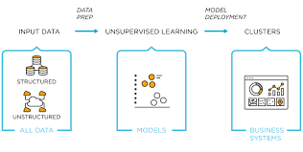

Key Characteristics:

**No Labels:** In unsupervised learning, the algorithm is not provided with labeled data, meaning there are no target labels or known outcomes for the input data.

**Exploratory Analysis**: Unsupervised learning is often used for exploratory analysis, where the objective is to gain insights into the underlying structure or distribution of the data.

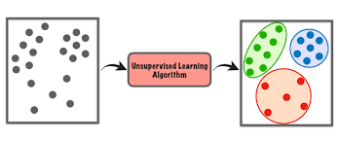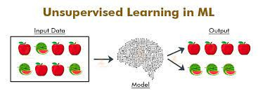

**Main Tasks in Unsupervised Learning:**

There are two primary tasks in unsupervised learning:

**Clustering:** Clustering algorithms group similar data points together based on their features or proximity. The goal is to identify natural groupings or clusters within the data. The algorithm does this by maximizing the similarity within clusters and minimizing the similarity between different clusters. Common clustering algorithms include k-means, hierarchical clustering, DBSCAN (Density-Based Spatial Clustering of Applications with Noise), and Gaussian Mixture Models (GMM).

**Dimensionality Reduction**: Dimensionality reduction techniques are used to reduce the number of features in the data while preserving essential information. High-dimensional data can be difficult to visualize and can lead to the curse of dimensionality. Dimensionality reduction helps overcome this by projecting the data into a lower-dimensional space while retaining meaningful information. Principal Component Analysis (PCA) and t-distributed Stochastic Neighbor Embedding (t-SNE) are common methods for dimensionality reduction.

Applications of Unsupervised Learning:

Unsupervised learning has various applications across different domains, including:

**Customer Segmentation**: Clustering customers based on their behavior and preferences to better target marketing campaigns and improve customer experience.

**Anomaly Detection:** Identifying abnormal patterns or outliers in data that might indicate potential fraud, defects, or errors.

**Recommendation Systems**: Suggesting products, services, or content to s based on their behavior and preferences.

**Data Compression:** Reducing the size of large datasets while retaining meaningful information through dimensionality reduction techniques.

**Image and Speech Recognition:** Extracting features from raw data for further processing in tasks like object recognition or speech analysis.

**Natural Language Processing**: Identifying patterns and topics within unstructured text data for tasks like topic modeling or sentiment analysis.

Unsupervised learning plays a critical role in exploring and understanding data when explicit labels or ground truth are unavailable. It is a powerful tool in a data scientist's toolkit and complements supervised learning techniques to provide a more comprehensive understanding of complex datasets.

**The Challenge of Unsupervised Learning**

Unsupervised learning presents several challenges that make it a complex and sometimes ambiguous task compared to supervised learning. Some of the key challenges include:

1. **Lack of Labels:** The primary challenge in unsupervised learning is the absence of labeled data. Without labeled examples, the algorithm must identify patterns and relationships solely based on the inherent structure of the data. This lack of guidance can make it difficult to assess the performance of the model objectively.
2. **Evaluation Metrics**: Since there are no explicit target values to compare predictions against, evaluating the performance of unsupervised learning algorithms becomes challenging. Traditional metrics used in supervised learning, such as accuracy or mean squared error, may not be applicable or meaningful in unsupervised settings.
3. **Ambiguity in Interpretation**: The output of unsupervised learning algorithms, such as clusters or reduced dimensions, may not always have clear and intuitive interpretations. Determining the optimal number of clusters or the significance of dimensions in dimensionality reduction can be subjective and context-dependent.
4. **Curse of Dimensionality:** Unsupervised learning can be adversely affected by the curse of dimensionality, especially in high-dimensional data. As the number of features increases, the data becomes more sparse, making it difficult to discover meaningful patterns.
5. **Clustering Validity:** In clustering tasks, deciding the appropriate number of clusters (k) is a crucial challenge. Selecting an inappropriate value of k can lead to either over-segmentation or under-segmentation, affecting the quality of the results.
6. **Data Preprocessing:** Preprocessing the data correctly is essential in unsupervised learning. Removing noise, handling missing values, and normalizing features can significantly impact the algorithm's performance and the quality of the discovered patterns.
7. **Computational Complexity:** Many unsupervised learning algorithms involve iterative optimization procedures, making them computationally intensive, especially for large datasets.
8. **Unbiased Representations:** In dimensionality reduction, ensuring that the reduced representations capture essential patterns without introducing bias or losing critical information is challenging.
9. **Outliers and Anomalies:** Unsupervised learning algorithms can be sensitive to outliers and anomalies, leading to suboptimal clustering or reduced dimensionality representations.
10. **Scalability:** Scaling unsupervised learning algorithms to large datasets can be difficult, as they may require significant computational resources and memory.

**Principal Components Analysis**

Principal Component Analysis (PCA) is a popular unsupervised learning technique used for dimensionality reduction and data compression. It transforms high-dimensional data into a lower-dimensional space while retaining as much of the original information as possible. PCA achieves this by finding the principal components, which are the orthogonal axes along which the data has the highest variance.

**Key Concepts:**

**Variance and Covariance**: PCA is based on the concept of variance and covariance. Variance measures the spread or dispersion of data points along a specific axis, while covariance measures the relationship between two variables.

**Principal Components:** The principal components are the new set of orthogonal axes obtained through PCA. The first principal component corresponds to the axis of maximum variance in the data, the second principal component is orthogonal to the first and has the second highest variance, and so on.

**Eigenvalues and Eigenvectors:** PCA involves computing the eigenvectors and eigenvalues of the covariance matrix of the data. Eigenvectors represent the directions of the principal components, and eigenvalues represent the amount of variance along those directions.

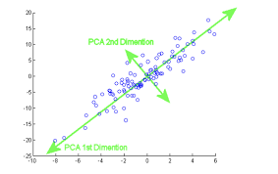

Steps of Principal Component Analysis:

The main steps involved in PCA are as follows:

Standardization: If the features in the dataset have different scales, it is essential to standardize them (mean centering and scaling by standard deviation) before applying PCA to ensure that each feature contributes equally to the analysis.

1. **Compute Covariance Matrix:** Calculate the covariance matrix of the standardized data, which describes the relationships between the different features.
2. **Compute Eigenvalues and Eigenvectors**: Compute the eigenvalues and eigenvectors of the covariance matrix. The eigenvectors represent the principal components, and the eigenvalues indicate the amount of variance explained by each principal component.
3. **Select Principal Components:** Order the eigenvalues in decreasing order and select the top k eigenvectors corresponding to the highest eigenvalues to obtain the first k principal components. These components will represent the lower-dimensional space.
4. **Project Data:** Project the original data onto the new lower-dimensional space defined by the selected principal components. This transformation reduces the number of features while retaining the most important information.

Applications of Principal Component Analysis:

PCA is widely used in various applications, including:

* **Dimensionality Reduction:** PCA reduces the number of features while preserving the most critical information, making it valuable in handling high-dimensional datasets.
* **Data Visualization:** By reducing data to a few principal components, PCA enables visualization of complex datasets in two or three dimensions.
* **Noise Reduction**: PCA can be used to remove noise from data, as the noise components are typically associated with low variance.
* **Feature Extraction**: PCA can be used as a feature extraction technique to generate new features that are combinations of the original features.
* **Data Compression:** PCA can compress data by representing it in a lower-dimensional space, leading to reduced storage requirements.

PCA is a powerful tool in data analysis and machine learning that aids in understanding the underlying structure of data and simplifying subsequent analysis.

**Missing Values and Matrix Completion**

Missing values in a dataset are gaps or placeholders where the data is unavailable or not recorded. Dealing with missing values is a common challenge in data analysis and machine learning because most algorithms cannot handle missing data directly. Matrix completion is a technique used to address this issue, particularly when dealing with datasets in tabular form, represented as matrices.

Handling Missing Values:

There are several approaches to handling missing values in a dataset:

1. **Removal/Dropping Rows or Columns**: The simplest approach is to remove rows or columns with missing values. However, this method can result in a significant loss of data, especially if many entries are missing.
2. **Mean/Median/Mode Imputation:** Missing values can be replaced with the mean, median, or mode of the non-missing values in the corresponding column. This method is straightforward but may introduce bias and distort the data distribution.
3. **Forward/Backward Fill:** In time series data, missing values can be filled using the most recent non-missing value (forward fill) or the next available non-missing value (backward fill). This approach is suitable when data has a temporal order.
4. **Interpolation**: Interpolation techniques estimate missing values based on the existing data points around them. Common interpolation methods include linear interpolation, polynomial interpolation, and spline interpolation.
5. **Advanced Imputation Methods:** There are more sophisticated imputation methods, such as k-nearest neighbors imputation, multiple imputation, and regression imputation, which take into account the relationships between features to predict missing values.

**Matrix Completion:**

Matrix completion is a specific technique used to estimate or fill in missing values in a matrix by exploiting the underlying structure or patterns in the data. It is especially useful when the dataset has many missing entries and the goal is to recover the complete matrix for subsequent analysis.

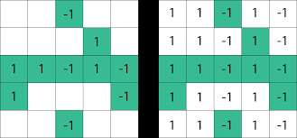

Matrix completion algorithms often use low-rank matrix approximation techniques, such as singular value decomposition (SVD) or matrix factorization. These methods aim to decompose the matrix into lower-dimensional matrices that capture the essential information in the data. By filling in the missing values in the lower-dimensional representation, the complete matrix can be reconstructed.

**Applications of Matrix Completion**:

Matrix completion has various applications in different fields, including:

**Recommendation Systems**: Matrix completion is used to fill in missing entries in a User -item interaction matrix to predict preferences and make personalized recommendations.

**Image Inpainting:** In image processing, matrix completion can be used to recover missing or corrupted parts of an image.

**Collaborative Filtering**: In collaborative filtering-based recommendation systems, matrix completion is employed to fill in missing User -item ratings.

**Genomics and Bioinformatics:** Matrix completion can be used to impute missing values in gene expression data or biological interaction networks.

Matrix completion algorithms are particularly useful when the missing data problem is pervasive and traditional imputation techniques are not sufficient.

**Clustering Methods**

Clustering is an unsupervised learning technique used to group similar data points together based on their features or proximity. Clustering methods aim to discover inherent patterns and structure within the data without any prior knowledge of class labels or target values. There are several clustering algorithms, each with its characteristics and use cases. Here are some of the most common clustering methods:

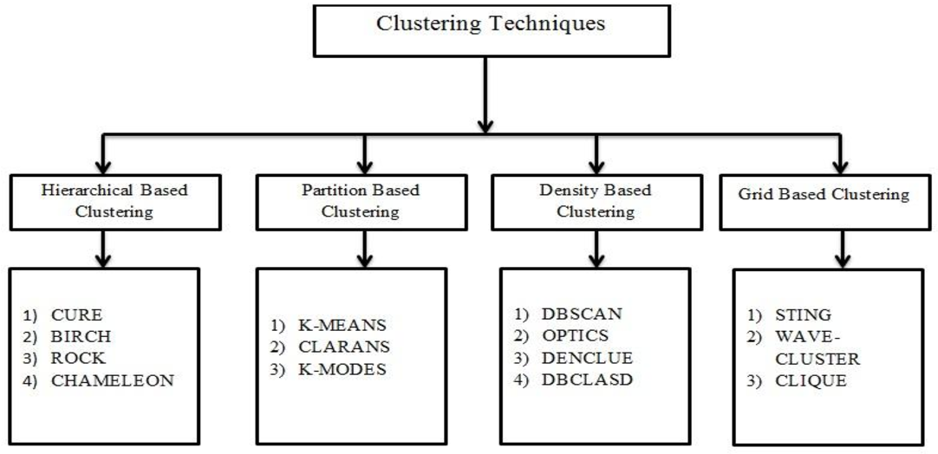

* **K-Means Clustering**: K-means is one of the most popular and widely used clustering algorithms. It aims to partition the data into k clusters, where k is a predefined number of clusters chosen by the . The algorithm iteratively assigns data points to the nearest cluster centroid and recalculates the centroids until convergence. K-means is efficient and works well for well-separated, spherical clusters.
* **Hierarchical Clustering:** Hierarchical clustering builds a tree-like structure of nested clusters, known as a dendrogram. The algorithm can be agglomerative (bottom-up) or divisive (top-down). Agglomerative hierarchical clustering starts with each data point as an individual cluster and merges the closest clusters at each step until all points belong to one cluster. Divisive hierarchical clustering begins with all data points in a single cluster and recursively divides the clusters until each data point forms its own cluster. Hierarchical clustering is useful for visualizing the clustering structure at different levels of granularity.
* **DBSCAN (Density-Based Spatial Clustering of Applications with Noise):** DBSCAN is a density-based clustering algorithm that groups data points into clusters based on their density. It identifies dense regions as clusters and separates outliers as noise. DBSCAN is effective in handling clusters of varying shapes and sizes and is not sensitive to the number of clusters, making it suitable for datasets with irregular densities.
* **Mean Shift Clustering:** Mean Shift is a non-parametric clustering algorithm that iteratively moves data points toward the mode of the data density. It tends to converge to the centers of clusters and is effective for datasets with complex shapes and varying densities.
* **Gaussian Mixture Models (GMM):** GMM assumes that the data is generated from a mixture of several Gaussian distributions. The algorithm aims to find the parameters of these Gaussian distributions, which represent the clusters. GMM is a probabilistic model, and each data point belongs to each cluster with a certain probability.
* **Spectral Clustering:** Spectral clustering uses the eigenvalues and eigenvectors of a similarity matrix to perform dimensionality reduction and clustering. It is effective for datasets with complex structures and is not limited to spherical clusters.
* **Affinity Propagation**: Affinity Propagation is a message-passing algorithm that identifies exemplars (representative data points) and assigns other data points to them based on similarity. It can be useful when the number of clusters is unknown.